**Project Design Phase-II**

**Data Flow Diagram & User Stories**

|  |  |
| --- | --- |
| Date | 10 march 2025 |
| Team ID | SWTID1741257592149925 |
| Project Name | InsightStream: Navigate the News Landscape |
| Maximum Marks | 4 Marks |

**Data Flow Diagrams:**

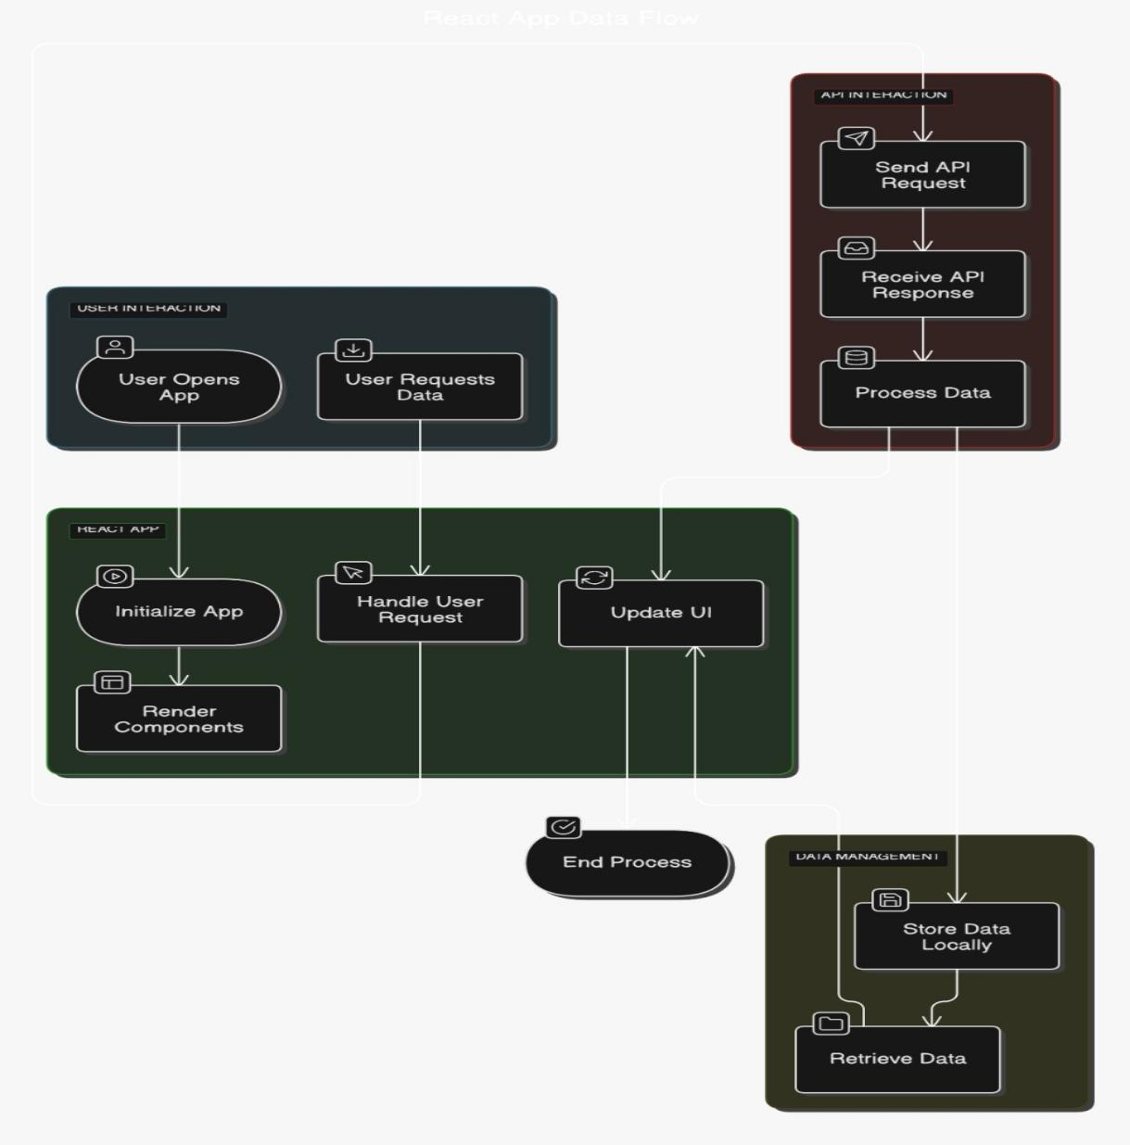

**User Stories**

**User Story Table – Music Streaming App**

|  |  |  |  |  |  |  |
| --- | --- | --- | --- | --- | --- | --- |
| **User Type** | **Functional Requirement (Epic)** | **User Story Number** | **User Story / Task** | **Acceptance Criteria** | **Priority** | **Release** |
| **News Reader** | News categories | USN-1 | As a user, I can read the news based on the category. | The user should be able to see real-time trending news from various sources. | High | Sprint-1 |
| **News Enthusiast** | Default news | USN-2 | As a user, I can see the trendy news at the default page | The user should be able to opt-in for daily or weekly email subscriptions. | High | Sprint-2 |
| **Mobile User** | Mobile-Friendly Experience | USN-4 | As a user, I want a fast and responsive news experience on mobile. | The app should be optimized for mobile devices with smooth scrolling. | High | Sprint-4 |
| **News Enthusiast** | News Browsing | USN-3 | As a user, I can read the complete article with courtesy. | The user should be able to opt-in for daily or weekly email subscriptions. | High | Sprint-3 |

A **News Reader** wants to stay updated with the latest trending news. They should be able to access real-time trending news from various sources, ensuring they are always informed about current events. This feature is essential for providing timely and relevant information, making it a high priority for **Sprint1**..

A **Mobile User** expects a **fast and responsive experience** while reading news on the go. Many apps struggle with performance issues on mobile devices, causing frustration among users. To address this, the app should be fully optimized for mobile browsing, ensuring smooth scrolling and a seamless interface. Given the increasing reliance on mobile devices for news consumption, this is a **high-priority feature for Sprint-4**